Subdivision by Lines or Segments

Definition
# Source: AI Source: Provided by: [Data Path: Persons Table -> ID Column: 1, Name_En Column: Motasem Essam] -> From: [ChatGPT] on [7/25/2026]
Subdivision by Lines or Segments is a method of decomposing a geometric figure by introducing one or more straight lines, line segments, or portions of straight lines within or across the figure to create smaller geometric regions.
The resulting regions may be triangles, quadrilaterals, polygons, or other simpler shapes. Depending on the construction, the regions may have equal or unequal areas and may be congruent or noncongruent.

Simple Definition
# Source: AI Source: Provided by: [Data Path: Persons Table -> ID Column: 1, Name_En Column: Motasem Essam] -> From: [ChatGPT] on [7/25/2026]
Subdivision by Lines or Segments is dividing a geometric figure into smaller regions by drawing straight lines or line segments.
For example, drawing a diagonal inside a rectangle divides it into two triangles.
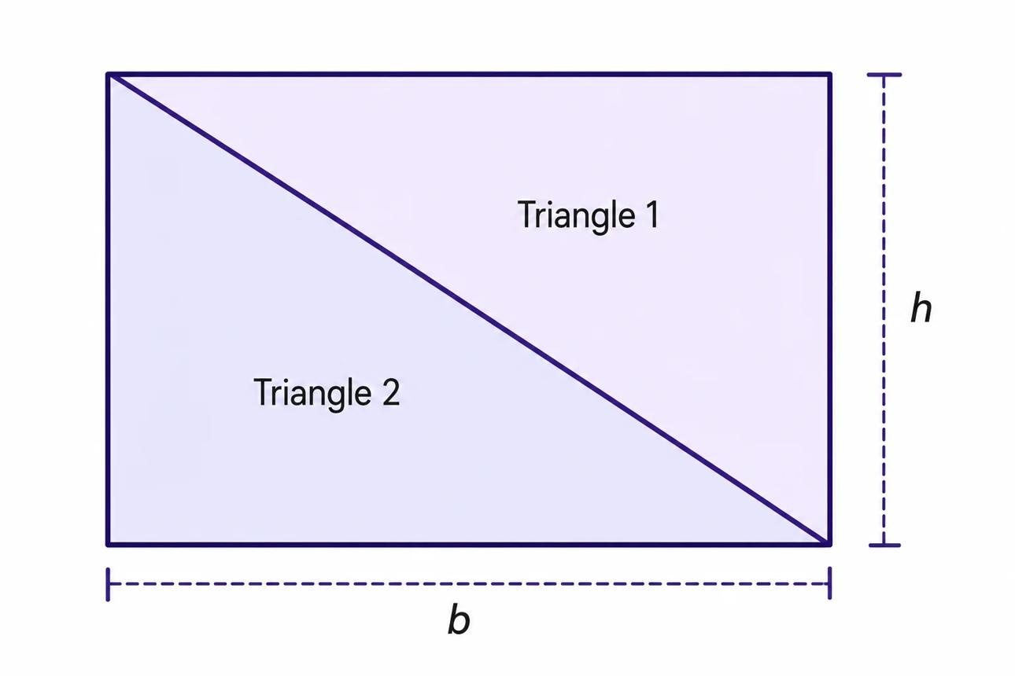
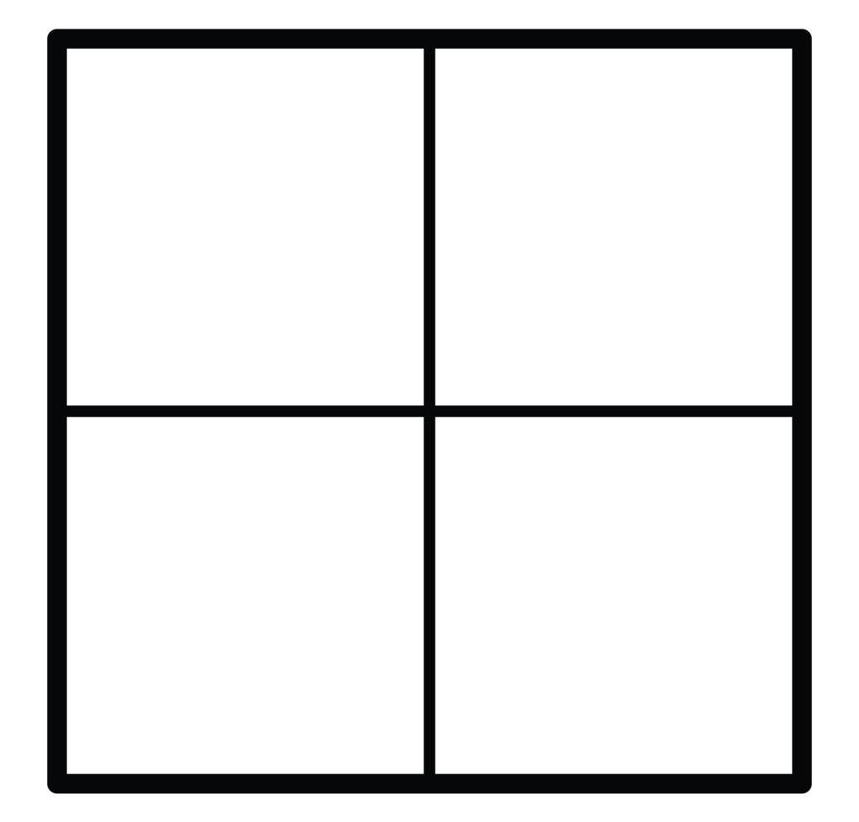
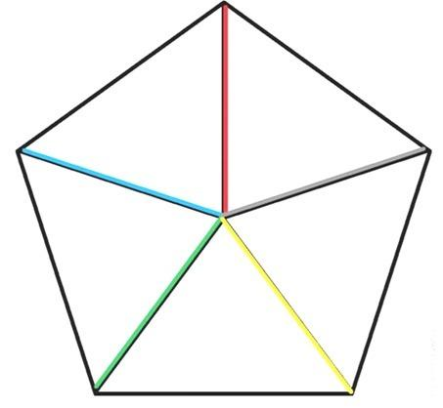

Main Classification
# Source: AI Source: Provided by: [Data Path: Persons Table -> ID Column: 1, Name_En Column: Motasem Essam] -> From: [ChatGPT] on [7/25/2026]
The following is a practical, descriptive classification, not a universally standardized taxonomy. Some categories overlap because a figure can be subdivided using several types of lines or segments simultaneously.

1. Diagonal-Based Subdivision
# Source: AI Source: Provided by: [Data Path: Persons Table -> ID Column: 1, Name_En Column: Motasem Essam] -> From: [ChatGPT] on [7/25/2026]
Uses a diagonal joining two nonadjacent vertices of a polygon to divide it into smaller regions.
Example: a rectangle divided into two triangles by one diagonal.
Detailed Explanation and Examples
Definition: A polygon is subdivided by drawing a diagonal between two nonadjacent vertices.
Example: A rectangle $ABCD$ has length $10$ units and width $6$ units. Draw diagonal $\overline{AC}$.
The diagonal creates two triangles, $△ABC$ and $△ACD$.
The rectangle's area is
$$A=10×6=60$$
Each triangle has area
$$A_{△}=\frac{12}{\left(10\right)}\left(6\right)=30$$
The two triangles have equal areas because the diagonal divides the rectangle into two congruent triangles.
Important: A diagonal divides a convex quadrilateral into two triangles. In other polygons, the diagonal's endpoints must be nonadjacent vertices, and the diagonal must lie within the polygon for an interior subdivision.

2. Vertex-Based Subdivision
# Source: AI Source: Provided by: [Data Path: Persons Table -> ID Column: 1, Name_En Column: Motasem Essam] -> From: [ChatGPT] on [7/25/2026]
Connects a selected vertex to other nonadjacent vertices to partition a polygon.
Example: drawing two diagonals from one vertex of a pentagon to divide it into three triangles.
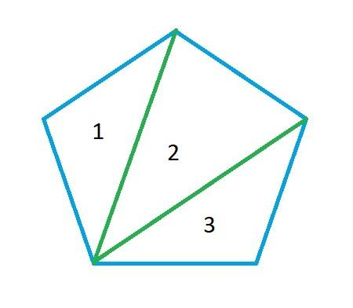
Detailed Explanation and Examples
Definition: A selected vertex is connected to nonadjacent vertices to divide a polygon into smaller regions.
Example: A convex pentagon $ABCDE$ is subdivided by drawing diagonals $\overline{AC}$ and $\overline{AD}$.
The pentagon is divided into three triangles:
$$△ABC, △ACD, △ADE$$
For a convex polygon with $n$ vertices, connecting one vertex to all its nonadjacent vertices creates
$$T=n-2$$
triangles. For the pentagon,
$$T=5-2=3$$
Important: This method works directly for convex polygons. For concave polygons, some diagonals from a chosen vertex may fall outside the figure.

3. Median-Based Subdivision
# Source: AI Source: Provided by: [Data Path: Persons Table -> ID Column: 1, Name_En Column: Motasem Essam] -> From: [ChatGPT] on [7/25/2026]
Uses a median joining a triangle's vertex to the midpoint of its opposite side.
Example: a triangle divided into two equal-area triangles by a median.
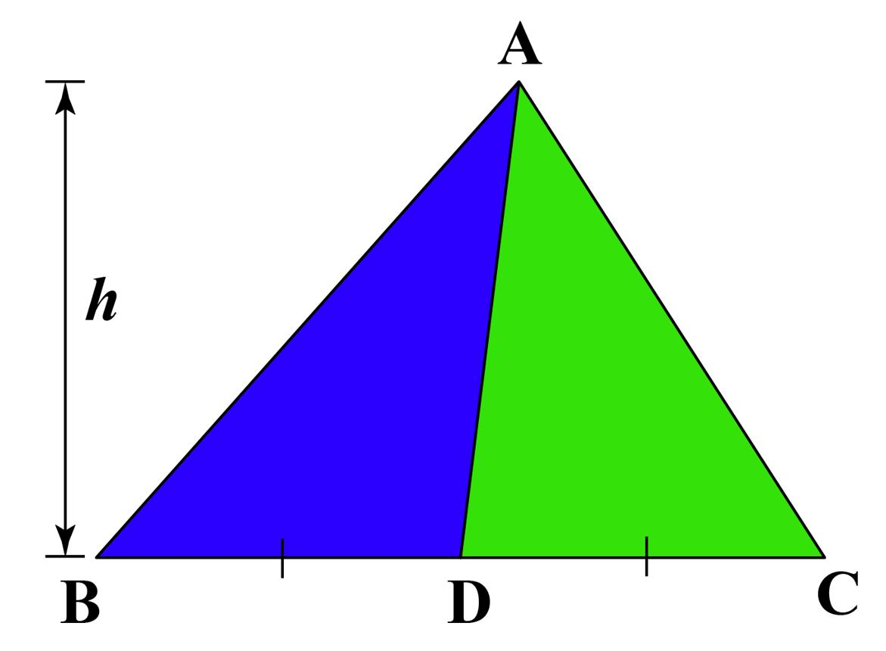
Detailed Explanation and Examples
Definition: A median divides a triangle into two smaller triangles by joining a vertex to the midpoint of the opposite side.
Example: In $△ABC$, let $D$ be the midpoint of $\overline{BC}$. Suppose $BC=12$ and the altitude from $A$ to $BC$ is $5$.
Since $D$ is the midpoint,
$$BD=DC=6$$
The total area is
$$A_{ABC}=\frac{12}{\left(12\right)}\left(5\right)=30$$
Each smaller triangle has area
$$A_{ABD}=A_{ACD}=\frac{12}{\left(6\right)}\left(5\right)=15$$
Important: Every median divides a triangle into two equal-area triangles, regardless of whether the original triangle is isosceles, scalene, acute, or obtuse.

4. Grid-Based Subdivision
# Source: AI Source: Provided by: [Data Path: Persons Table -> ID Column: 1, Name_En Column: Motasem Essam] -> From: [ChatGPT] on [7/25/2026]
Uses intersecting horizontal and vertical segments to create a grid of smaller regions.
Example: dividing a square into nine smaller squares using two horizontal and two vertical interior segments.
Detailed Explanation and Examples
Definition: A figure is divided by intersecting horizontal and vertical line segments to form a grid.
Example: A square with side length $12$ units is divided into a $3×3$ grid.
The total area is
$$A={12}^{2}=144$$
There are nine smaller squares, so
$$A_{\text{cell}}=\frac{144}{9}=16$$
Each small square has side length $4$ units.
Important: A grid does not automatically create equal regions. Equal-area cells result when the grid divisions are appropriately spaced and the original figure has a suitable shape.

5. Triangulation-Based Subdivision
# Source: AI Source: Provided by: [Data Path: Persons Table -> ID Column: 1, Name_En Column: Motasem Essam] -> From: [ChatGPT] on [7/25/2026]
Divides a polygon into triangles using a collection of noncrossing diagonals.
Example: dividing a convex hexagon into four triangles.
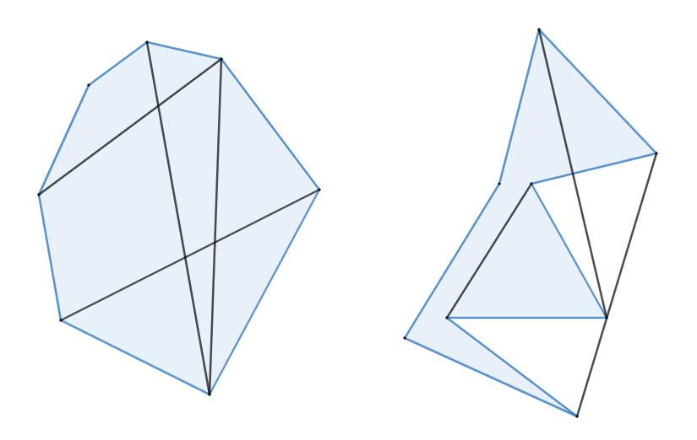
Detailed Explanation and Examples
Definition: Triangulation subdivides a polygon into triangles using noncrossing diagonals.
Example: A convex hexagon is triangulated using diagonals drawn from one vertex.
The number of triangles is
$$T=n-2=6-2=4$$
If the four triangle areas are $8$, $10$, $12$, and $14$ square units, then the hexagon's total area is
$$A=8+10+12+14=44$$
Important: A convex polygon with $n$ vertices can be triangulated into $n-2$ triangles. A simple concave polygon also admits a triangulation, but its diagonals must remain inside the polygon.

6. Rectangular Subdivision
# Source: AI Source: Provided by: [Data Path: Persons Table -> ID Column: 1, Name_En Column: Motasem Essam] -> From: [ChatGPT] on [7/25/2026]
Introduces horizontal and vertical segments to divide a rectilinear figure into rectangles.
Example: decomposing an L-shaped region into two rectangles.
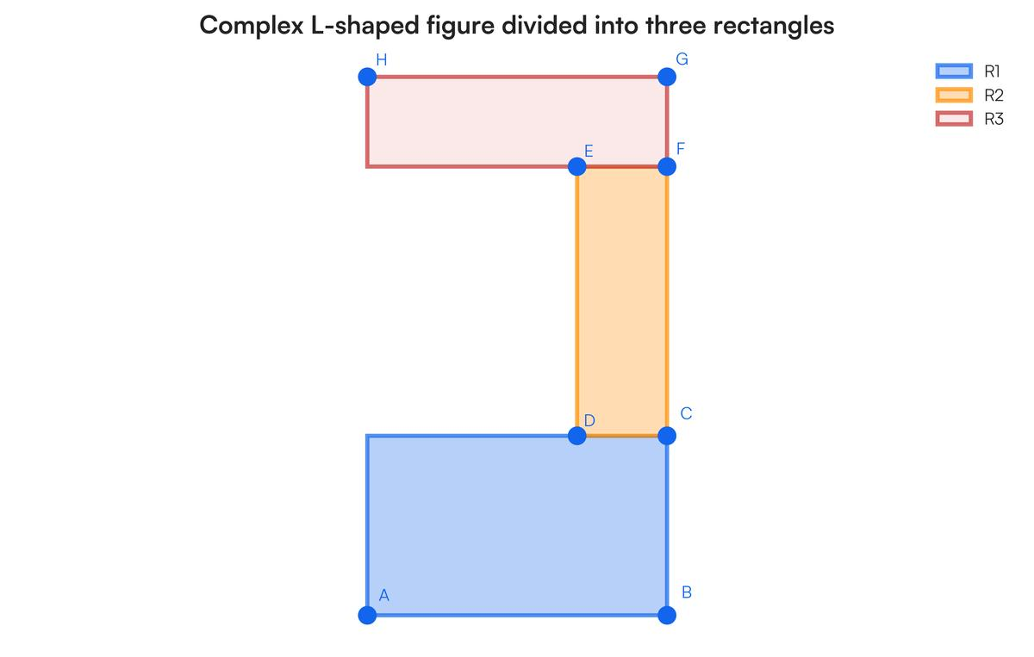
Detailed Explanation and Examples
Definition: A rectilinear figure is divided into rectangular regions using horizontal and vertical segments.
Example: An L-shaped figure consists of a $10×8$ outer rectangle with a $4×5$ rectangular corner removed.
The remaining area is
$$A=10\left(8\right)-4\left(5\right)$$
$$A=80-20=60$$
Alternatively, the figure can be subdivided into two rectangles with dimensions $6×8$ and $4×3$:
$$A=6\left(8\right)+4\left(3\right)=48+12=60$$
Both methods give the same area.
Important: Rectangular subdivision is particularly useful for calculating areas of L-shaped, stepped, and other rectilinear figures.

7. Chord-Based Subdivision
# Source: AI Source: Provided by: [Data Path: Persons Table -> ID Column: 1, Name_En Column: Motasem Essam] -> From: [ChatGPT] on [7/25/2026]
Uses chords—segments whose endpoints lie on a circle—to divide a circular region.
Example: two chords crossing inside a disk and producing several smaller regions.
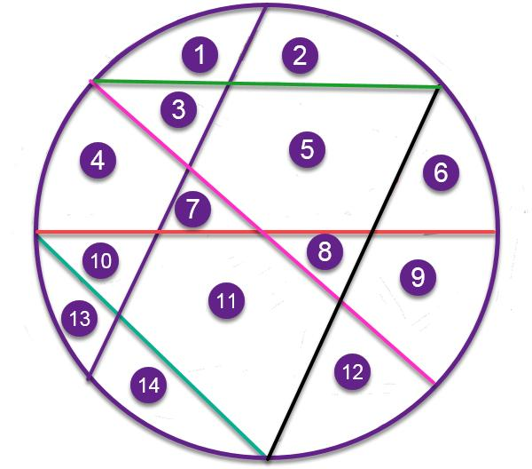
Detailed Explanation and Examples
Definition: A circular region is subdivided by drawing chords whose endpoints lie on the circumference.
Example: Two distinct chords intersect inside a disk of radius $5$ units, dividing the disk into four regions.
The disk's total area is
$$A=π{\left(5\right)}^{2}=25π$$
If the four regions have areas $A_{1},A_{2},A_{3},A_{4}$, then
$$A_{1}+A_{2}+A_{3}+A_{4}=25π$$
The four areas need not be equal.
Important: Chords divide a circular region into smaller regions bounded by straight segments and circular arcs. Equal-area regions require additional geometric conditions.

8. Parallel-Line Subdivision
# Source: AI Source: Provided by: [Data Path: Persons Table -> ID Column: 1, Name_En Column: Motasem Essam] -> From: [ChatGPT] on [7/25/2026]
Uses parallel lines or segments to divide a figure into strips or bands.
Example: dividing a rectangle into four horizontal strips.
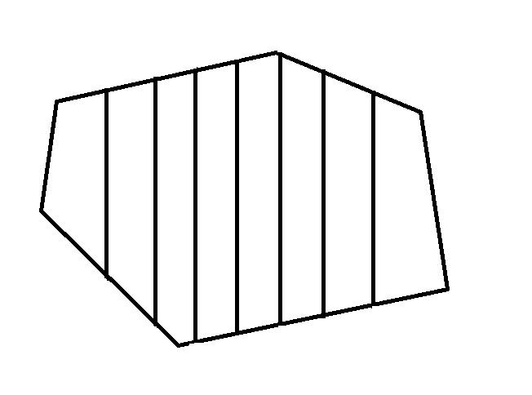
Detailed Explanation and Examples
Definition: Parallel lines or segments divide a figure into strips or bands.
Example: A rectangle of length $15$ units and width $8$ units is divided into four equal horizontal strips.
The total area is
$$A=15\left(8\right)=120$$
Each strip has area
$$A_{\text{strip}}=\frac{120}{4}=30$$
The width of each strip is
$$w=\frac{84}{=}2$$
Important: Parallel lines create strips, but the strips have equal areas only when the spacing and the figure's geometry make their areas equal.

9. Cevian-Based Subdivision
# Source: AI Source: Provided by: [Data Path: Persons Table -> ID Column: 1, Name_En Column: Motasem Essam] -> From: [ChatGPT] on [7/25/2026]
Uses cevians—segments joining triangle vertices to points on the opposite sides—to create smaller triangular regions.
Example: drawing three medians in a triangle to create six smaller triangles.
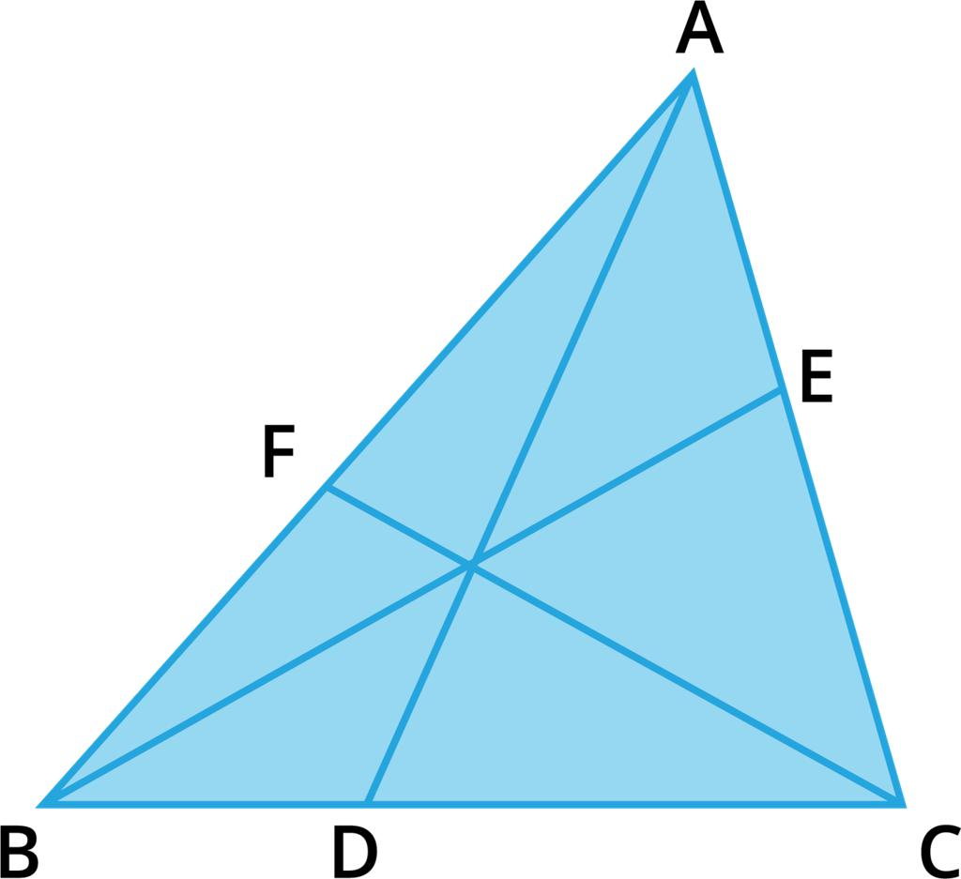
Detailed Explanation and Examples
Definition: A cevian is a segment joining a vertex of a triangle to a point on the opposite side or its supporting line.
Example: Draw all three medians of a triangle. The medians intersect at the centroid and divide the triangle into six smaller triangles of equal area.
If the original triangle has area $36$ square units, then each small triangle has area
$$A_{\text{small}}=\frac{36}{6}=6$$
Important: Three arbitrary cevians do not necessarily create six equal-area triangles. The equal-area result applies when the three cevians are the triangle's medians.

10. Multiple-Segment Subdivision
# Source: AI Source: Provided by: [Data Path: Persons Table -> ID Column: 1, Name_En Column: Motasem Essam] -> From: [ChatGPT] on [7/25/2026]
Uses several interior segments, potentially from different vertices or boundary points, to produce multiple regions.
Example: dividing a polygon into triangles and quadrilaterals using several internal segments.
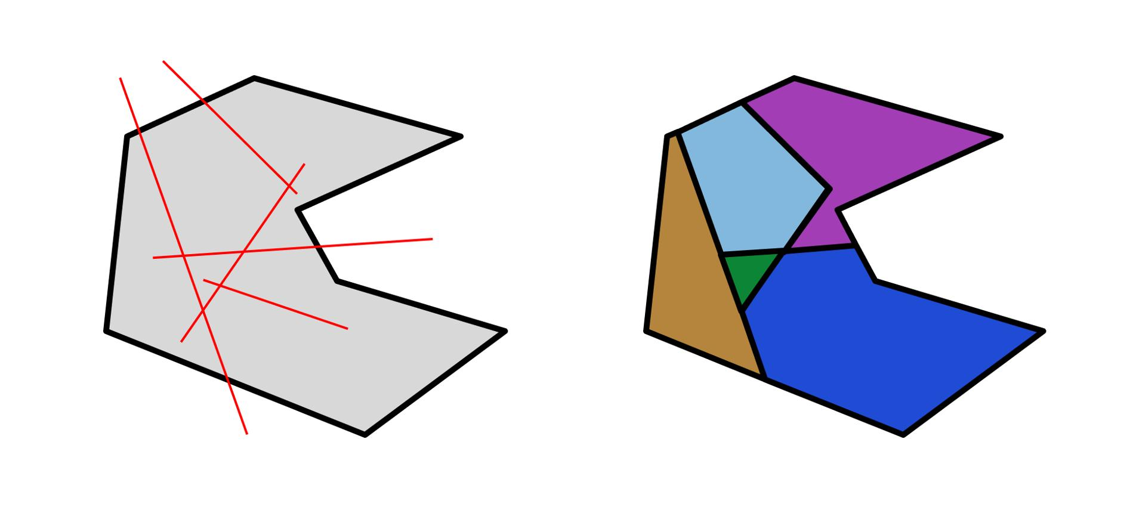
Detailed Explanation and Examples
Definition: Several interior segments are introduced to divide a figure into multiple regions, potentially with different shapes.
Example: A convex hexagon is triangulated from one vertex, creating four triangles. An additional segment is drawn inside one of those triangles from a vertex to its opposite side, splitting that triangle into two.
The total number of regions increases from four to five.
If the original triangle areas were $8$, $10$, $12$, and $14$ square units, and the triangle of area $10$ is split into areas $4$ and $6$, the new total remains
$$A=8+4+6+12+14=44$$
Important: Adding an interior segment subdivides an existing region without changing the total area of the original figure, provided the subdivision introduces no gaps or overlaps.

Key Formulas
# Source: AI Source: Provided by: [Data Path: Persons Table -> ID Column: 1, Name_En Column: Motasem Essam] -> From: [ChatGPT] on [7/25/2026]
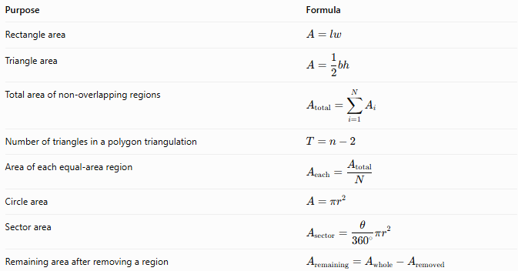
Purpose | Formula
Rectangle area | $$A=lw$$
Triangle area | $$A=\frac{1}{2}bh$$
Total area of non-overlapping regions | $$A_{\text{total}}=\sum_{i=1}^{N}{A_{i}}$$
Number of triangles in a polygon triangulation | $$T=n-2$$
Area of each equal-area region | $$A_{\text{each}}=\frac{A_{\text{total}}}{N}$$
Circle area | $$A=πr^{2}$$
Sector area | $$A_{\text{sector}}=\frac{θ}{{360}^{∘}}πr^{2}$$
Remaining area after removing a region | $$A_{\text{remaining}}=A_{\text{whole}}-A_{\text{removed}}$$
Here, $N$ is the number of regions, $n$ is the number of polygon vertices, $l$ and $w$ are rectangle dimensions, and $r$ is the circle's radius.

Comparison with Other Decomposition Types
# Source: AI Source: Provided by: [Data Path: Persons Table -> ID Column: 1, Name_En Column: Motasem Essam] -> From: [ChatGPT] on [7/25/2026]
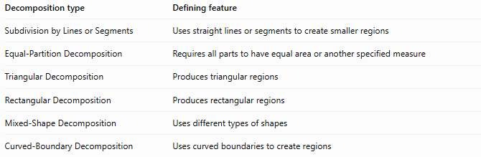
Decomposition type | Defining feature
Subdivision by Lines or Segments | Uses straight lines or segments to create smaller regions
Equal-Partition Decomposition | Requires all parts to have equal area or another specified measure
Triangular Decomposition | Produces triangular regions
Rectangular Decomposition | Produces rectangular regions
Mixed-Shape Decomposition | Uses different types of shapes
Curved-Boundary Decomposition | Uses curved boundaries to create regions
These classifications can overlap. For example, triangulation-based subdivision is both a form of subdivision by segments and a form of triangular decomposition.

Classification Summary
# Source: AI Source: Provided by: [Data Path: Persons Table -> ID Column: 1, Name_En Column: Motasem Essam] -> From: [ChatGPT] on [7/25/2026]
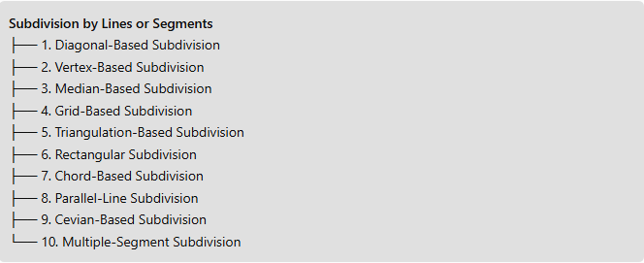
Subdivision by Lines or Segments
├── 1. Diagonal-Based Subdivision
├── 2. Vertex-Based Subdivision
├── 3. Median-Based Subdivision
├── 4. Grid-Based Subdivision
├── 5. Triangulation-Based Subdivision
├── 6. Rectangular Subdivision
├── 7. Chord-Based Subdivision
├── 8. Parallel-Line Subdivision
├── 9. Cevian-Based Subdivision
└── 10. Multiple-Segment Subdivision

Key Points
# Source: AI Source: Provided by: [Data Path: Persons Table -> ID Column: 1, Name_En Column: Motasem Essam] -> From: [ChatGPT] on [7/25/2026]
- Subdivision by lines or segments creates smaller regions within a geometric figure.
- The new regions may have equal or unequal areas and may have different shapes.
- Diagonals and triangulations are particularly useful for polygonal figures.
- Medians and cevians are especially useful for subdividing triangles.
- Chords subdivide circular regions, while horizontal and vertical segments are useful for grid-based and rectangular subdivisions.
- Subdivision preserves the total area when the regions cover the original figure without gaps or overlaps.

Conclusion
# Source: AI Source: Provided by: [Data Path: Persons Table -> ID Column: 1, Name_En Column: Motasem Essam] -> From: [ChatGPT] on [7/25/2026]
Subdivision by Lines or Segments is a general geometric decomposition method that uses straight boundaries to divide a figure into smaller regions. Its practical forms include diagonal-based, vertex-based, median-based, grid-based, triangulation-based, rectangular, chord-based, parallel-line, cevian-based, and multiple-segment subdivision. The appropriate method depends on the original figure, the desired shapes of the resulting regions, and the geometric properties that need to be preserved or established.

